Preservation of Multiple Point Structure when Conditioning by Kriging

WEISHAN REN, LUCIANE CUNHA AND CLAYTON V. DEUTSCH
Department of Civil & Environmental Engineering, 220 CEB,
University of Alberta, Canada, T6G 2G7

Abstract. The idea of conditioning by kriging is well known in theory and practice. It has been used for conditioning the realizations from unconditional simulation techniques such as the moving average and the turning bands simulation approaches. The basis of the conditioning by kriging approach is to use the same variogram for both the unconditional simulation and the kriging. In this paper, the focus is on using kriging for conditioning of more complex unconditional simulations. Unconditional simulated realizations with multiple point structure are generated for posterior conditioning. Two sets of data are used for kriging. After conditioning, the simulated values at data locations are the real data values, so the local data is honored. Beyond the range of correlation, the simulated values are the unconditional simulated values, which mean that the multiple point structure can be preserved.

The results obtained in this work show that conditioning by kriging is a simple, easy and reliable way to account for data with complex multiple point structures. Both continuous and categorical variables are used to show the performance of the conditioning by kriging approach. Moreover, kriging with different sets of data demonstrates that the multiple point structures are well preserved after conditioning.

- Introduction

Conditioning by kriging is not a new concept in geostatistics. It has been used for conditioning the moving average and the turning bands simulations (Journel and Huijbregts, 1978). However, because the sequential simulation is quite feasible and widely accepted, the conditioning by kriging has been little used in practice.

When working on reservoir characterizations, we often need to deal with complex features. Two-point statistical simulations are not good at preserving these complex features. So multiple-point statistic is usually needed. However, multiple-point statistic is very complicated and always takes a very long time. Object-base simulation can also be used to model the complex features. But conducting a conditional simulation with complex features takes much longer time than an unconditional simulation. If carrying out an unconditional simulation to capture these complex features, then apply the conditioning by kriging to obtain a conditional simulation, the conditional simulation with complex features can be performed in an easy and fast manner. In this paper, the focus is on the conditioning by kriging. The unconditional simulation realizations are generated by using the fluvsim (Deutsch and Tran, 2001) and contain channels and overbank with non-linear features. The conditioning by kriging is conducted to show how these multiple point structures can be preserved. The performance of conditioning by kriging will be shown in both continuous and categorical variables cases.

- Theory of Conditioning by Kriging

Suppose there are N real data, and M data need to be simulated. The conditioning by kriging consists of the following successive steps:
- Carry out an unconditional simulation to obtain the unconditional simulated values Z_{uc}(x).
- Carry out kriging using the N conditioning data to obtain Z_{kr}(x).
- Carry out kriging using the unconditional simulated values at these N data locations to obtain Z_{kr-u}(x).
- Calculate the conditional simulation values for each block:

This equation implies that at each real data location, the unconditional simulated value is taken out, and the conditioning datum is put in. Near the location, the kriging linear estimators smooth the change between the real data and the unconditional simulated values outside the range of kriged values. Therefore, after the conditioning, the conditional simulated values at these N data locations will exactly be the real data values. Beyond the range of correction, the conditional simulated values will be the unconditional simulated values. These steps need to be carried out in the Gaussian environment.

The two kriging (steps 2 and 3) can be combined to perform only one kriging using N data differences between the real data and the unconditional simulated values. Then the conditioning can be simply expressed as:

where D_{kr}(x) is the data of the kriging using the residual of the real data values subtracting the unconditional simulated values.

It can be interpreted as that the conditioning by kriging is adding correction areas to unconditional simulations based on the differences between real data and unconditional simulated values. This can be easily seen in an example (Figure 1). This example is constructed using categorical variables. The unconditional simulation realizations and the string of conditioning data are shown together in the left image. The result of conditioning by kriging is shown in the right image. The channel is in dark grey, and the overbank is in light grey. For the places in overbank where the conditioning data shows there should be a channel, a certain size of channel is added by conditioning. In the example, a channel is added beside the original channel so that the result looks like the original channel is dilated. In the contrary, for the places where the conditioning data shows there should be no channel, erosion takes place.

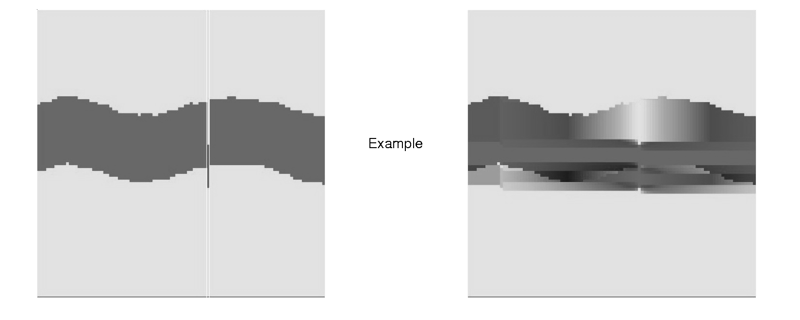
Figure 1. Example of conditioning by kriging.

Continuous and categorical variables are used to show the performance of the conditioning by kriging approach. The real data can be obtained from continued cores in a single well or from different wells. Therefore, for each variable, the conditioning data use a string of data and scattered data. They are extracted from an unconditional simulation.

- Continuous Variable Cases

  - CONDITIONING WITH A STRING OF DATA

A string of data used for the conditioning is shown in Figure 2. The real data actually are only one pixel wide. In order to show them clearly in a plot, the string of data is extended to five pixels. The data domain is 100 by 100.

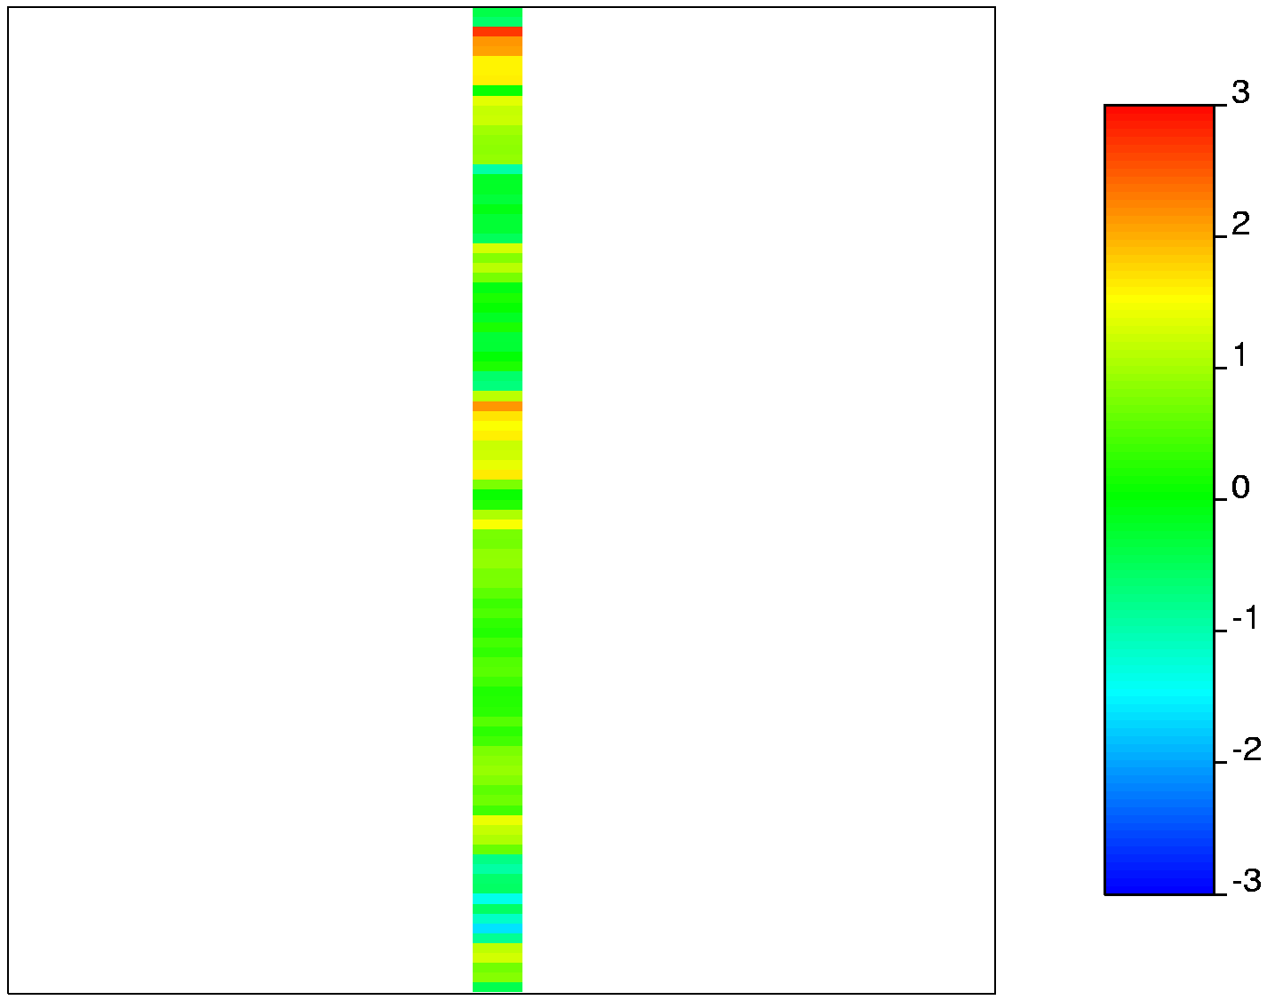
Figure 2. A 1-D string of conditioning data expanded to five pixels. The real data is one pixel wide at index 50 in a 100 x 100 pixel image. The normal scale is used throughout.

The unconditional simulation was implemented using the fluvsim to generate realizations with channels and overbank deposits. Within the channels and overbank deposits, a separated sgsim (Deutsch and Journel, 1998) was implemented to generate the realizations for each deposit. The four unconditional simulation realizations were transformed into Gaussian space and are shown in Figure 3. These curvilinear channels are laying out in the vertical direction. The normal scores of these unconditional simulation realizations were used to calculate variograms. The varfit (Larrondo et. al., 2003) was used to model the variograms, and the variogram models were used in the kriging. The models of variograms in the vertical and horizontal directions of the first unconditional simulation realization (the top left image in Figure 3) are shown in Figure 4. The residual data was calculated by subtracting the unconditional simulated values from the conditioning data values. Therefore, using these residual data, only one kriging was implemented. The kriged values were added to the unconditional simulated values to calculate the conditional simulation values.

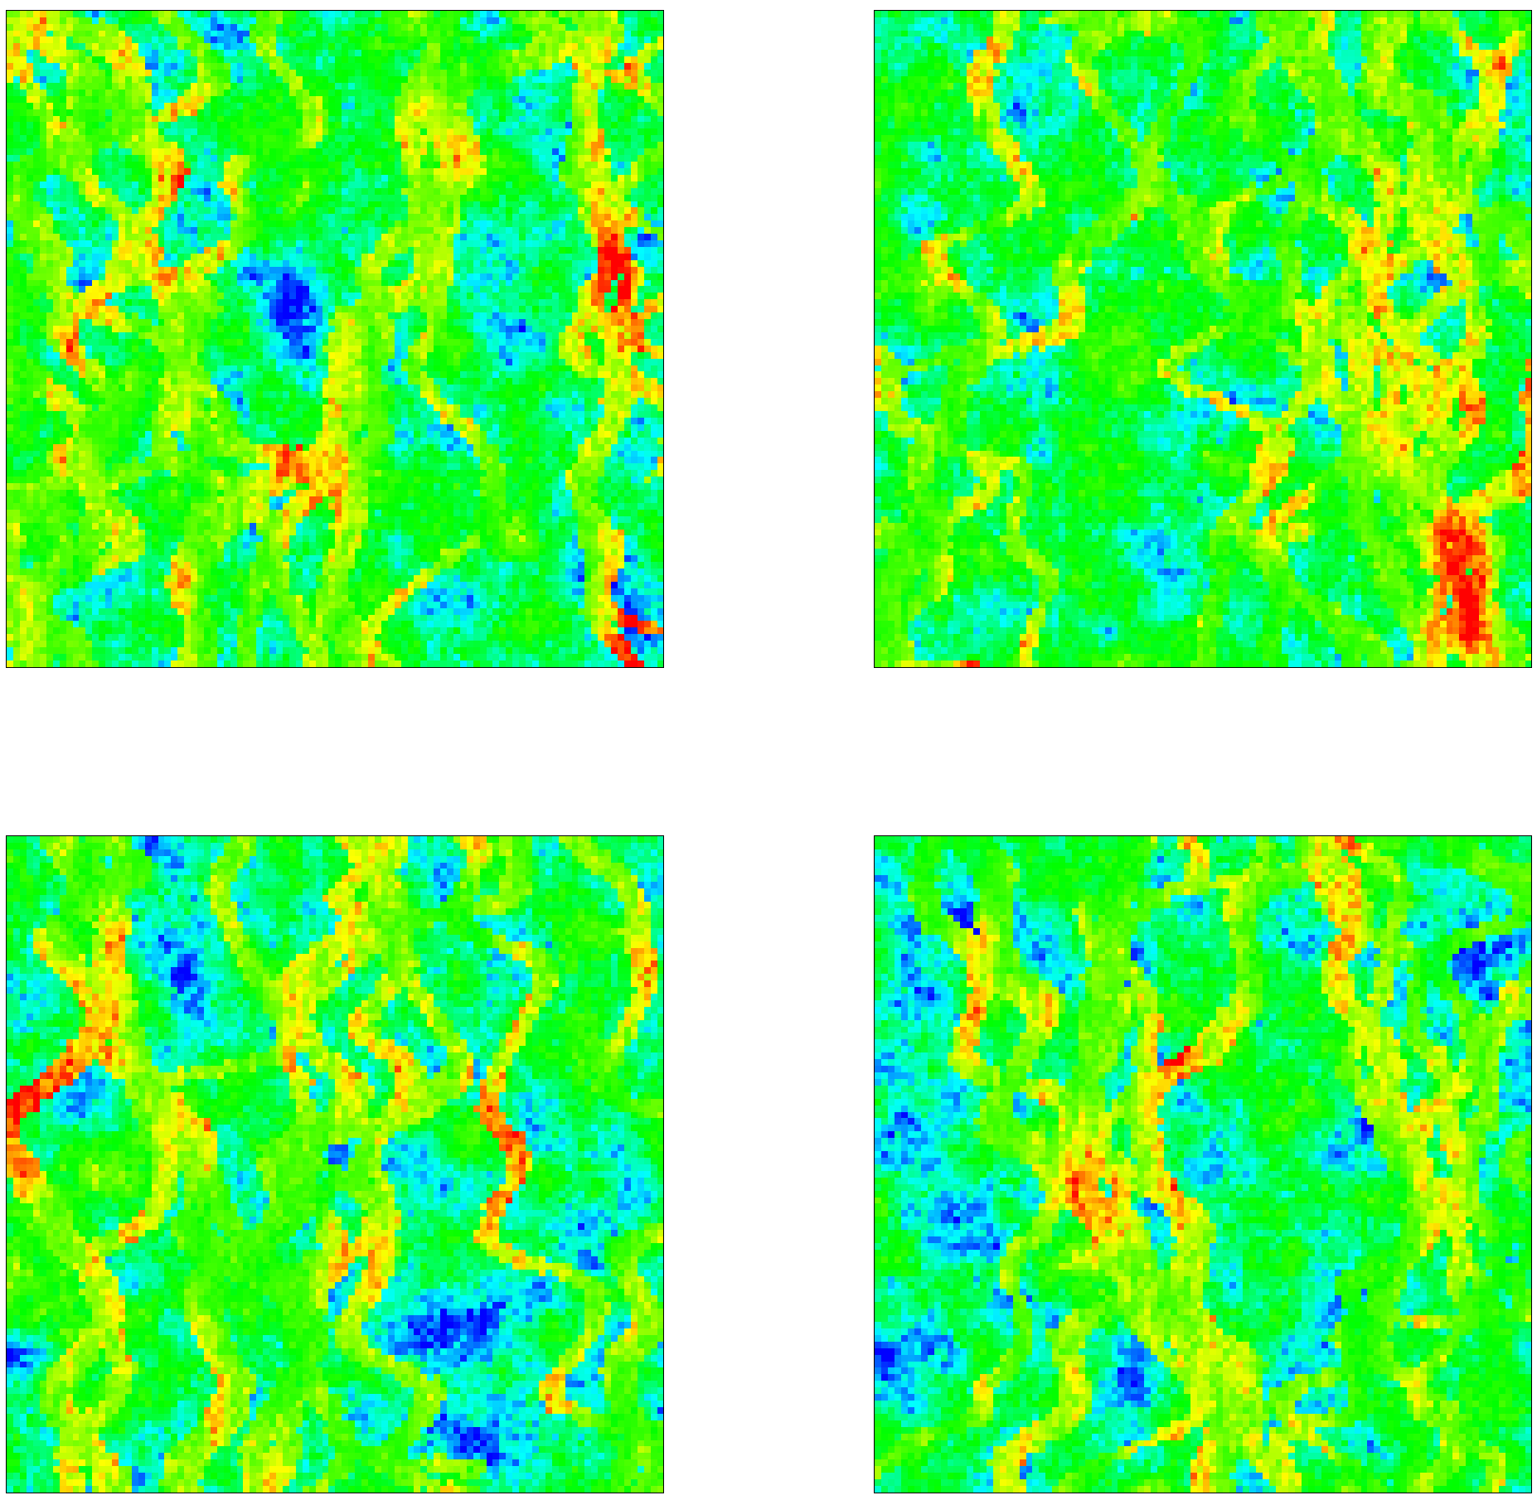
Figure 3. Four unconditional realizations generated by fluvsim and then separate sgsim runs within the channel and overbank deposits.

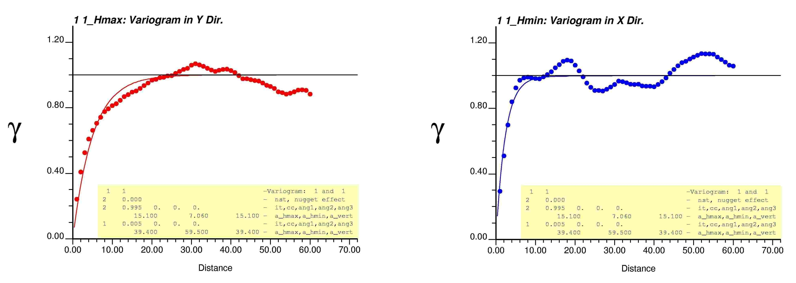
Figure 4. Variograms of the first unconditional realization in two main directions.
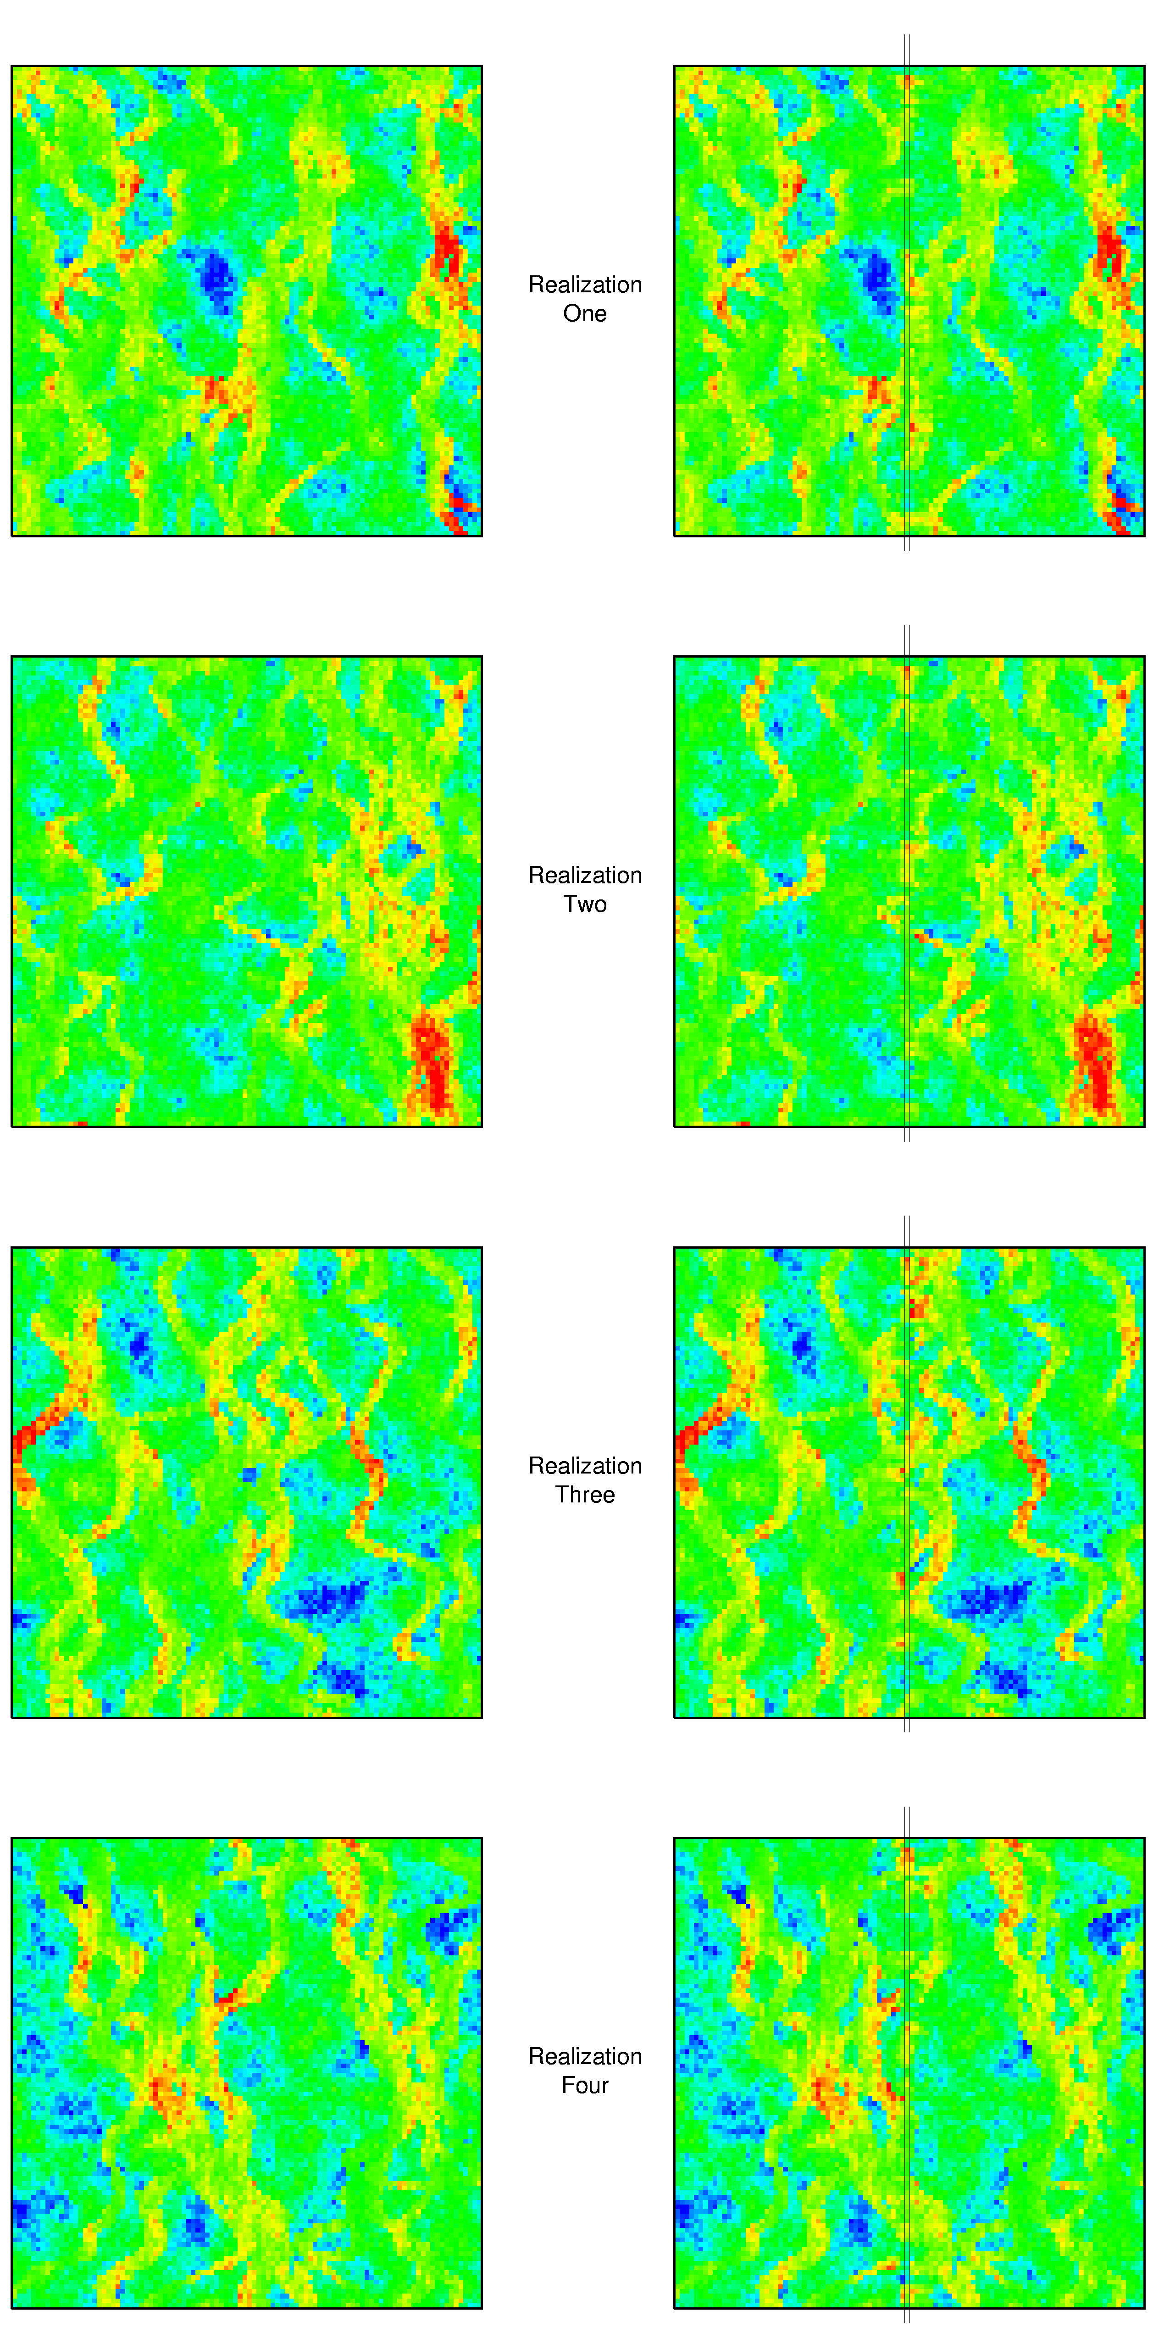
Figure 5. The left column is four unconditional simulation realizations, and the right column is these realizations conditioned by kriging. The central data location matches exactly the conditioning data shown on Figure 2.
The conditional simulation realizations are shown in the right column of Figure 5. For comparison, the four unconditional simulation realizations are plotted in the left column of Figure 5. It can be seen that near the center line of the realizations, there are some difference created by the conditioning. Beyond that, they are exactly same. Apparently, the multiple-point structures are well preserved.

  - CONDITIONING WITH SCATTERED DATA

The scattered data used for the conditioning by kriging are shown in Figure 6. The data are taken at ix/iy grid node indices of 10, 30, 50, 70 and 90.

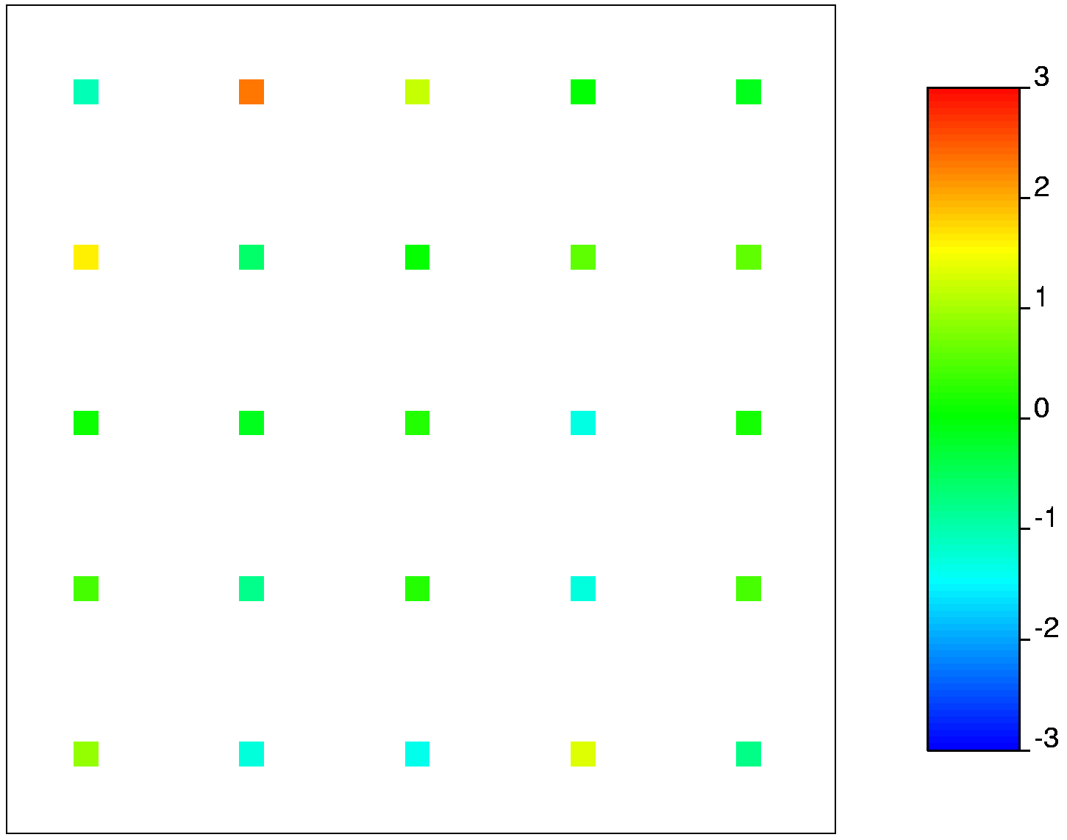
Figure 6. Scattered conditioning data: the data are taken at ix/iy grid node indices of 10, 30, 50, 70, and 90.

The same approach has been applied for conditioning the four unconditional simulation realizations (Figure 3) with the 25 scattered data. Both the conditional simulation results and the unconditional simulation results are shown in Figure 7. The conditioning data are honored and the multiple-point structures are well preserved.

- Categorical Variable Cases

  - CONDITIONING WITH A STRING OF DATA

Similarly to the continuous variable case, a string of data was used for conditioning (Figure 8). The data are categorical values of 1 and 0. The channel categorical value is 1 and shown in dark grey. The overbank categorical value is 0 and shown in light grey. The real data is only one pixel wide at index 50 in a 100 by 100 pixel image, and it is also expanded to five pixels to show them better. Two unconditional simulation realizations (the left column in Figure 9 or 11) were generated with fluvsim. The data are also categorical values of 1 and 0. These curvilinear channels are laying out in the vertical direction. The despike was used to change the same categorical values into slightly different values so that the 1 : 1 normal score transformation could be achieved. The categorical values of the unconditional simulated data and the conditioning data were despiked, and transformed into normal scores. The variograms were calculated from the unconditional realizations and modeled by the varfit program. These models were used in the kriging.
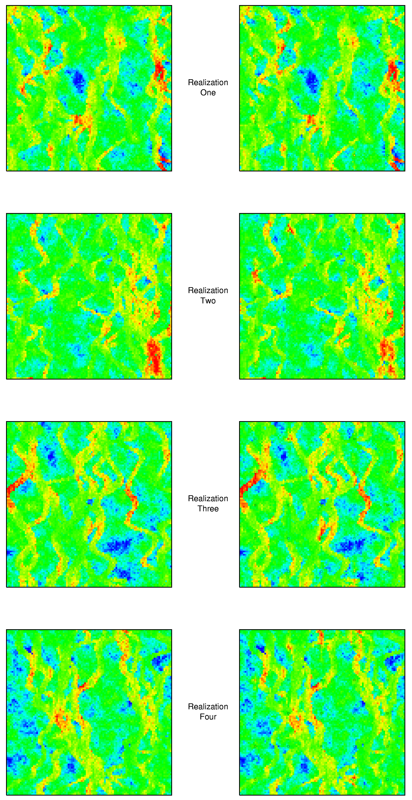
Figure 7. The left column is four unconditional simulation realizations, and the right column is these realizations conditioned by kriging to 25 scattered data. They match the conditioning data exactly and the non-linear structure is preserved quite closely.
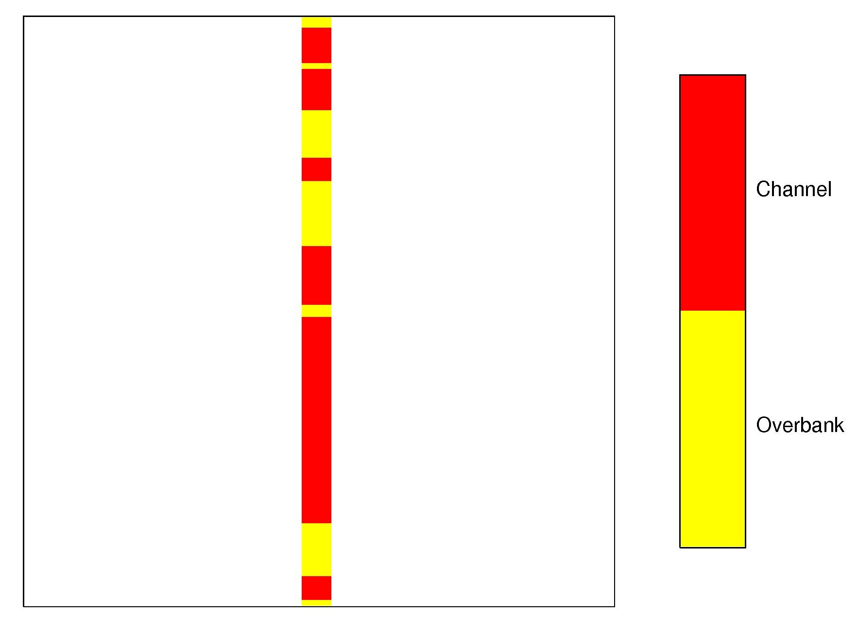
Figure 8. A string of conditioning data for the categorical variable case. The data is expanded to five pixels.

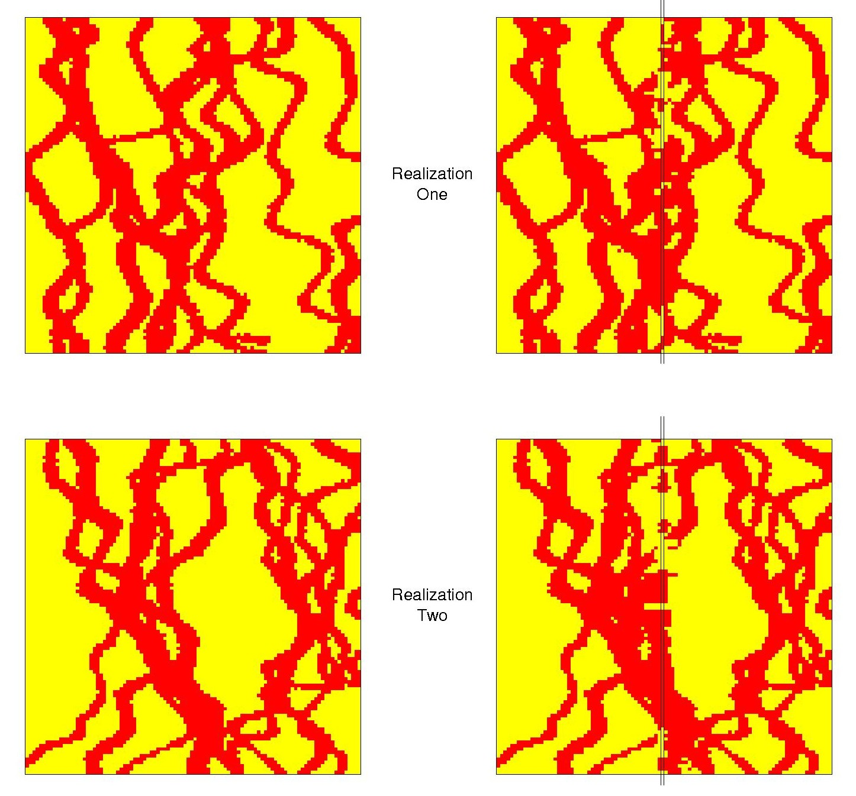
Figure 9. Two unconditional simulation realizations are on the left, and the realizations conditioned by kriging to the string of data are on the right. These conditioned models match the conditioning data.

The residual data were calculated in Gaussian space. After kriging with the residual data, the kriged results were added to the unconditional simulated data to get the conditional simulated data. These values were normal scores but not categorical values. So they were truncated into categorical values of 1 and 0.

The conditional simulation realizations are shown in the right column in Figure 9. The models on the right match the conditioning data. There are some artifacts when large changes occur, but apparently, the non-linear structures are well preserved.
  - CONDITIONING WITH SCATTERED DATA

The scattered data used for the conditioning by kriging are shown in Figure 10. The data are taken at ix/iy grid node indices of 10, 30, 50, 70 and 90. The same approach has been applied for conditioning the unconditional simulation realizations. Both the unconditional and the conditional simulation results are shown in Figure 11. Some artifacts appear when facies changes. But certainly the multiple-point structures are well preserved.

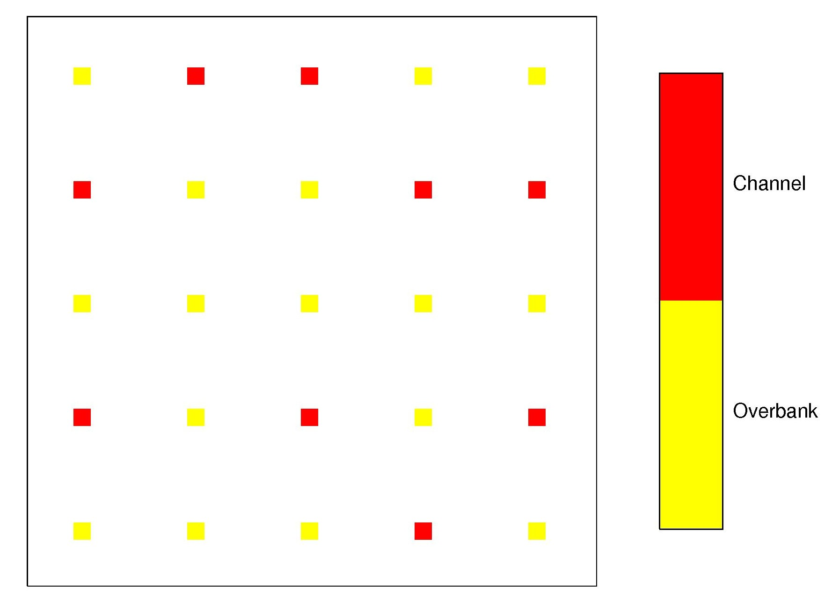
Figure 10. 25 scattered conditioning data for the categorical variable case. The data are taken at grid node indices of 10, 30, 50, 70 and 90.
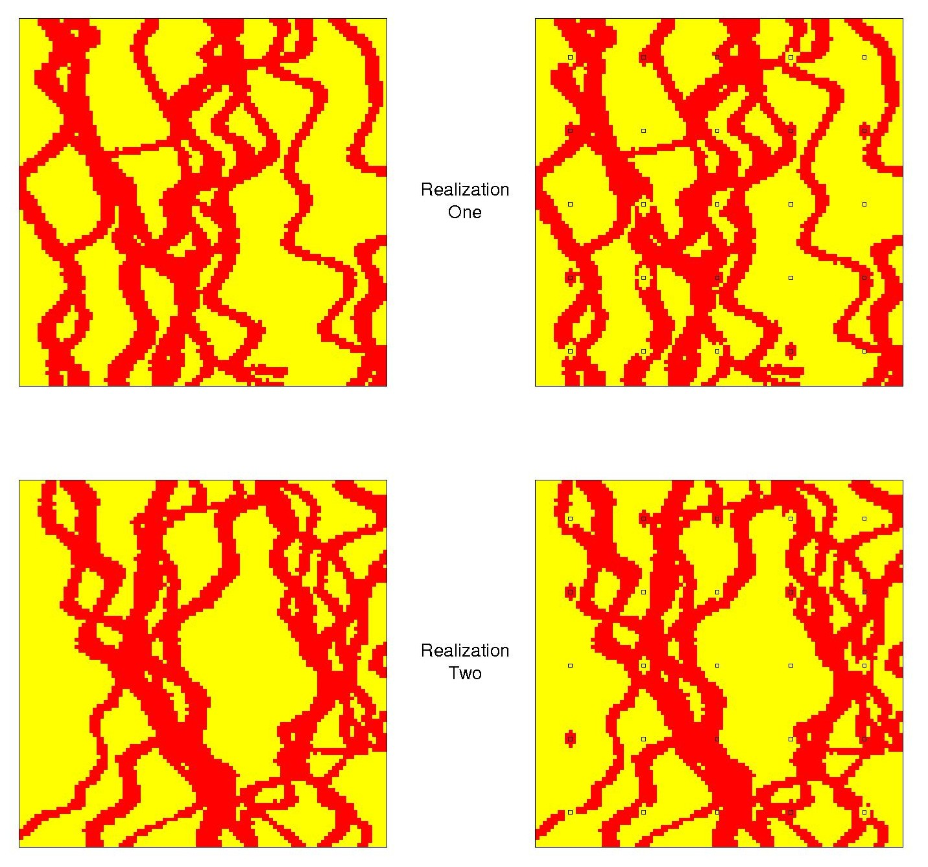
Figure 11. Two unconditional simulation realizations are on the left, and the realizations conditioned by kriging to the scattered data are on the right. These conditioned models match the conditioning data.
- Conclusions

Conditioning by kriging is correct when dealing with unconditional realizations based on the simple kriging principle. The conditional realizations respect the data and have no artifacts of the conditioning data. Using kriging to condition realizations that are generated by more complex simulation algorithms has been demonstrated with limited success. The shape/structure of the changes near the conditioning data respects mostly the variogram. The greater the change required, the greater the influence of the variogram and the poorer the complex structure is preserved. The algorithm would work well when the changes are minimal (such as a near solution with annealing) or when the features are reasonably captured by the variogram.

References

Deutsch, C.V. and Journel, A.G., GSLIB: Geostatistical Software Library and User’s Guide, 2nd Edition, Oxford University Press, 1998.
Deutsch, C.V. and Tran, T.T., FLUVSIM: a program for object-based stochastic modelling of fluvial depositional systems, Computers & Geosciences, vol. 28, 2002, p. 525-535.
Larrondo, P.F., Neufeld, C.T. and Deutsch, C.V., VARFIT: A program for Semi-Automatic Variogram Modelling. In Center for Computational Geostatistics Report Five, University of Alberta, Edmonton, Alberta, 2003.
Journel, A.G. and Huijbregts, C.J., Mining Geostatistics, Academic Press, 1978.

